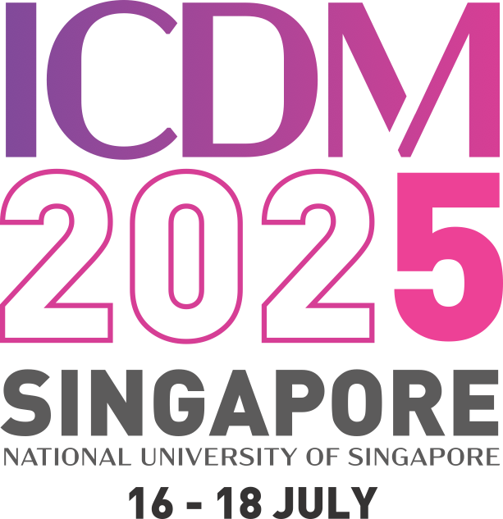

**The Fifth International Conference on Damage Mechanics (ICDM5)**

Date: 16th - 18th July 2025

Venue: National University of Singapore

|  |  |
| --- | --- |
| **Abstract Title** | A review of continuum damage and plasticity in concrete |
| **List of authors & their affiliations with the presenter’s name underlined. Provide email contact for the presenter.** | Taehyo Park1, Bilal Ahmed1, George Z. Voyiadjis2  1Hanyang University  2 Louisiana State University  Email: [cegzv1@lsu.edu](mailto:cegzv1@lsu.edu) |
| **Abstract** | |
| In the past few decades, extensive research on concrete modeling to predict behavior, crack propagation, microcrack coalescence by utilizing different approaches (fracture mechanics, continuum damage mechanics) were investigated theoretically and numerically. The presented work aims to review the theoretical work of continuum concrete damage and plasticity modeling. | |