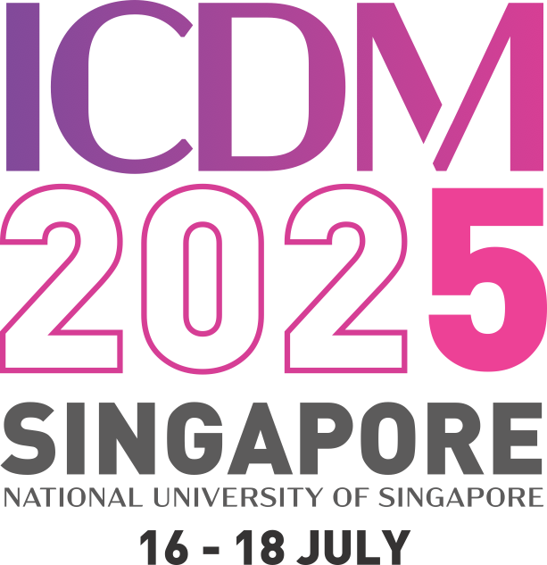

**The Fifth International Conference on Damage Mechanics (ICDM5)**

Date: 16th - 18th July 2025

Venue: National University of Singapore

|  |  |
| --- | --- |
| **Mini Symposium Title** | Computational modelling of fracture in quasi-brittle materials |
| **Short description on the focus of the Mini Symposium** | The mini-symposium aims to provide a platform for discussion of the newest theoretical and numerical developments at all stages, length scales and time scales of inelastic material responses, until complete failure has developed in quasi-brittle materials. |
| **Organizers** | Leong Hien Poh, National University of Singapore  Ron Peerlings, Eindhoven University of Technology |